Test Data Lab 2

|  |  |  |  |
| --- | --- | --- | --- |
| NO# of  Screenshot | Diameter | Volume (hand calculated) | Volume (resulting output) |
| 1 | 2 | 4.189 | 4.188790204666666 |
| 2 | 25.4 | **8,580.247** | 8580.246645805719 |
| 3 | -5 | **-65.45** | -65.44984694791665 |

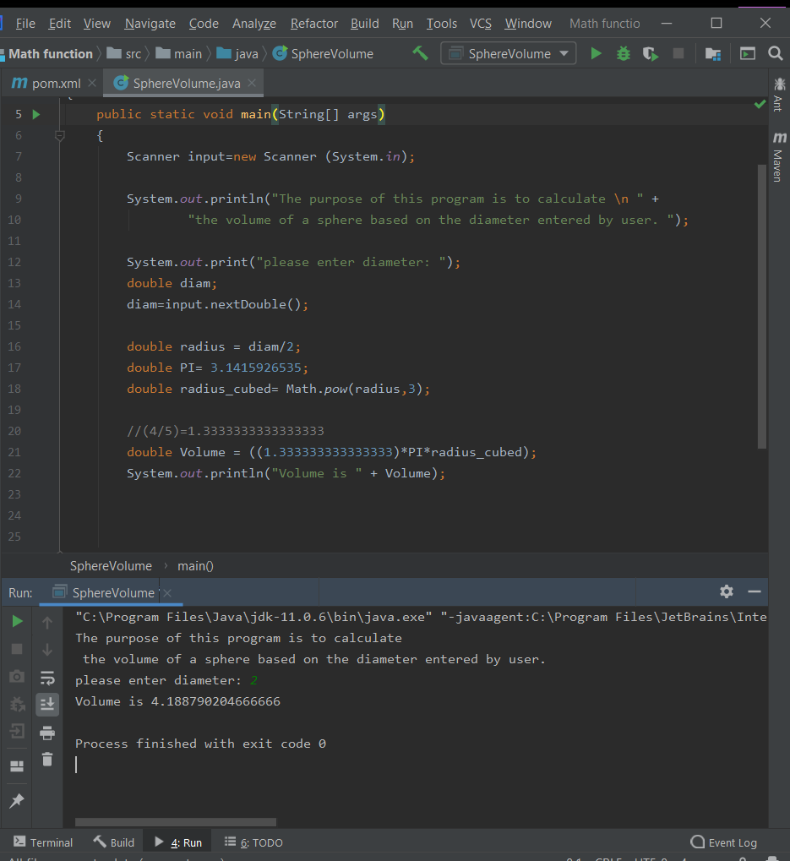NO# 1

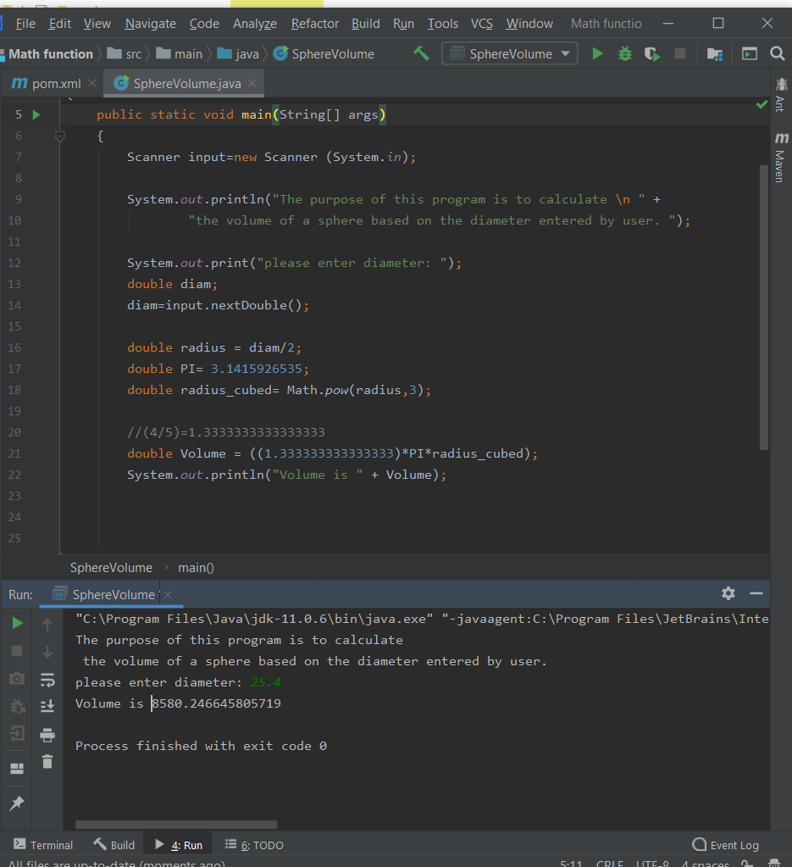NO# 2

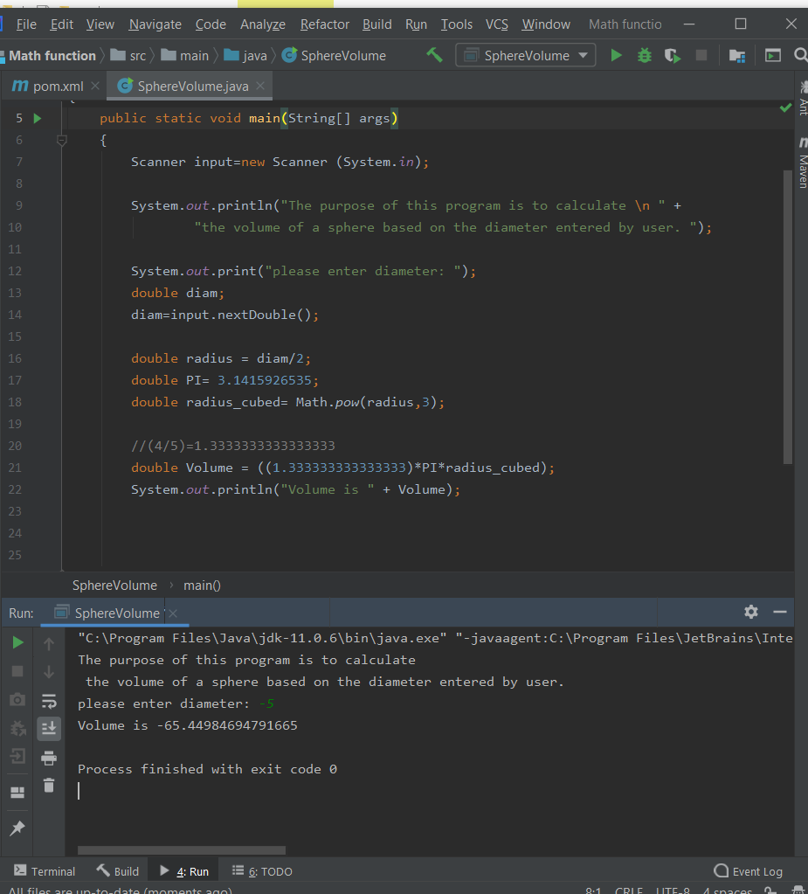NO# 3